Group size: 4.1pax
Period: September 2019
Date | City | Schedule |  | Meal
D1 | Kunming- | Arrival Kunming, Meet our Tour guide and transfer to Check in hotel.  ãLocal 4* Camellia hotel or similar https://hotels.ctrip.com/hotel/1718080.html | AIR | D
D2 | Kunming- Dali | By bus to Dali, Chongsheng Three pagodas temple (Outlook), Erhai wetland park, Visit Dali ancient town (exclude buggy) + Foreigner street  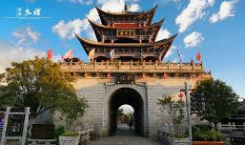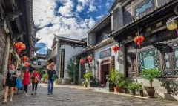  ãLocal 4* DALI N hotel or similar https://www.mafengwo.cn/hotel/7107202.html | v | BLD
D3 | Dali - Lijiang | Visit Xizhou White minority village+ Three course tea performance. By bus to Lijiang, Visit Lijiang ancient city, Square street, Black Dragon lake...  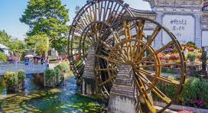  ãLocal 4* Green Melody holiday hotel or similar http://hotels.ctrip.com/hotel/107597.html | v | BLD
D4 | Lijiang | Visit Jade Snow Mountain- Yunshanping (include cable car), Blue moon cave, Dry sea, Jade water village, Impression Lijiang show.  ãLocal 4* Green Melody holiday hotel or similar 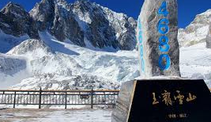 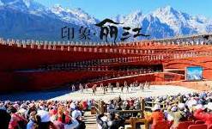 | v | BLD
D5 | Lijiang- Kunming | By bus to Kunming 7-8hours, Visit Golden horse memorial Arch, Nanping street  ãLocal 4* Camellia hotel or similar  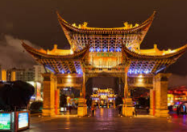 | v | BLD
D6 | Kunming | transfer out. | v | B

Special meal:
- Noodle over bridge
- Xizhou minority cuisine
- Yunnan’s Specialty

Tour Fare (use 9seater MPV) :RMB 3500/pax (5+0FOC) Single supplement. RMB 570

Remarks:
1) Include meal, Mandarin guide (every city one local guide), Entrance ticket, hotel (twin sharing)
2) Exclude Tips- Usd 5/pax/day， Optional tour (Guide suggest), air ticket, bell boy
3) Compulsory Shopping: NO
4) Meal budget: RMB 70/pax/meal
5) Child with bed: 100% Child no bed: 75% (Child no bed exclude hotel breakfast)
6) FOC based on twin sharing
7) Free one mineral water per pax per day 350ml
8) IF Need english guide, Additional RMB 600/groups

